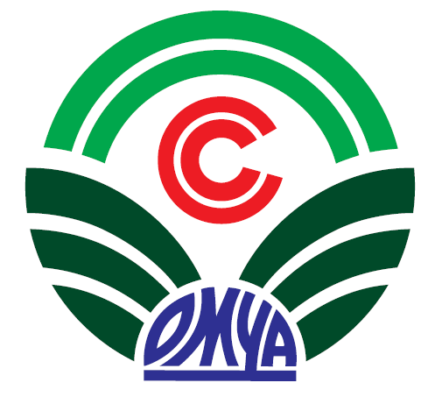 | SURINT OMYA VIETNAM CO., LTD.
Work Location  Contact | Dongnai Plant, Go Dau Industrial Zone, Long Thanh, Dong Nai Province.  (Transportation: not provided)  Send CV to email: hr.sov.vn@gmail.com  For further information or if you have any support please feel free to contact HR Dept as below:  - Tel: 0283 6296 9260 – Ext 203  - Website: www.omya.com
Benefits | AS BELLOW
Basis | - Salary range depends on skills and experience (VND20,000.000 - 24,000,000);  - Social – health – unemployment insuarance;  - Annual leave compliance laws;  - Meal allowance;  - Per diem allowance.
Others | - Annual salary review;  - Annual performance bonus;  - Training course;  - Health and accident insuarance 24/24;  - Health check up (at least 1 time per year);  - Provident fund;  - Company trip, team building;  - Uniform, helmets, overcoat;  - Birthday leave, Christmas leave;  - Gift: birthday, marriage, new born, 08/3, 01/6, 30/4, 02/9, 20/10, New year, Lunar new year.
Job title | ASSISTANT PLANT MANAGER
Core Responsibilities | - Direct and coordinate Plant operations within Company policies and procedures;  - Maintain a clean, warehouse keeping and safe plant;  - Establish and direct Plant policies and procedures;  - Responsible for Plant production goals;  - Establish and maintain a positive community relationship;  - Foster a well-trained and motivated staff;  - Confer with department heads to ensure coordination of purchasing, production, and shipping;  - Responsible for establishing all shift production schedules;  - Conduct employee performance reviews;  - Responsible for the product quality control for the Plant;  - Attend scheduled corporate training and meetings;  - Other duties as assigned.
Job requirement | - Bachelor degree in Engineering (EE, ME are preferable. IE is acceptable), age 35 - 40 years, excellent command in English;  - At least 5 years experience in equivalent or related industry (International Company is preferred);  - Need to have good management and communication skill with proper attitude match to corporate behaviours;  - Need to have high analytical skill with a lot of common sense lead to problem solving, planning, implementation and control to meet company goals and objectives;  - Need to have team spirit and leadership.

